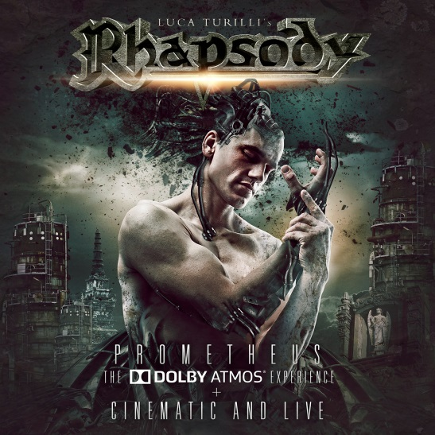

**Luca Turilli’s RHAPSODY**

»Prometheus«

The Dolby Atmos Experience

+

»Cinematic And Live«

*OUT: December 9th, 2016*

|  |  |
| --- | --- |
| **Line-up:** | **Luca Turilli’s RHAPSODY online:** |
| Luca Turilli | guitars, keyboards  Dominique Leurquin | guitars  Patrice Guers | bass  Alex Landenburg | drums  Alessandro Conti | vocals | [www.ltrhapsody.com](http://www.ltrhapsody.com)  [www.facebook.com/ltrhapsody](http://www.facebook.com/ltrhapsody)  [www.nuclearblast.de/rhapsody](http://www.nuclearblast.de/rhapsody) |

The latest album of **Luca Turilli's RHAPSODY**, **»Prometheus, Symphonia Ignis Divinus«**, was chosen to be the first studio album in music history to be remixed in **Dolby Atmos**. Renowned producer/mixing engineer **Chris Heil** (**DAVID BOWIE, BRYAN ADAMS, SCORPIONS**) mixed the entire masterpiece in **Dolby Atmos** - the mindblowing result will be submitted for the 2017 Grammy nominations. **»Prometheus, The Dolby Atmos Experience + Cinematic And Live«** will be released December 9th via **Nuclear Blast**.

**Luca Turilli**, responsible for composition and orchestra- and choir-arrangements states:

*“The new Dolby Atmos sound fits perfectly with Luca Turilli's RHAPSODY music just as the RHAPSODY music - emotional, visionary and cinematic in its nature - is perfect to showcase the potential of an amazing technology destined to revolutionize the field of immersive audio's experience. From a composer's point of view, Dolby Atmos is like the advent of a canvas with colors in three dimensional space. It enables me to place the band, orchestra and choir around me like I would in a real life situation, granting to the listener an emotional and breathtaking journey in a parallel dimension. Every instrument can finally breathe and live in three dimensions, turning the Dolby Atmos version of RHAPSODY's music into a divine, musical experience of transcendence. No limits for creativity anymore. This new Dolby technology allows my heart and soul to finally express themselves with complete freedom and exciting force!”*

But what actually is **Dolby Atmos**? Cinemas discovered this new format and integrated loud speakers in their ceilings to place the listener into an 'acoustic honeycomb´.

*“This novelty has now reached the home technology and we at Yamaha wanted to support the project of Luca Turilli's RHAPSODY with an audio-bluray-disc in Dolby Atmos”,* **Michael Geise** from Yamaha explains. *“It's a very thrilling challenge and makes this release a vivid and new experience. And since we are always looking for new contents, the cooperation with Luca Turilli was a great idea for us. Dolby Atmos is already included in our receivers and the customer can immediately use it - but so far only few releases support this new format and usually it is only available for films, not for music blurays. But now it is and we created a medium that could easily bring instruments to life, without any artifical effects. We had the know-how to turn this performance into a real live experience with our loudspeakers, receivers and the new sound bar that brings the musicians almost right into everyone's living room!”*

Producer and mixer **Chris Heil** found **Luca Turilli's** **RHAPSODY** almost by accident: *“I heard excerpts from »Prometheus, Symphonia Ignis Divinus« in the studio right next to me and knew immediately that this was the material I wanted to use to showcase the potential of Dolby Atmos to the world. This kind of music is made for this format with its combination of band, orchestra and choir arrangements. I called Luca Turilli immediately to ask his permission to use the material and he immediately agreed.”*

The result of their two months long cooperation is a vivid combination of metal, filmscore and a wide variety of ethnic elements. *“It is incredibly entertaining and inspiring to listen to the result. It's the first album in my 36-year career where I had to leave longer pauses between the tracks because you really need time to digest that bombastic sound. It's mindblowing,”* states **Chris Heil**. And **Luca Turilli** agrees: “*Dolby Atmos will bring a revolution to the world of films and music and allows you to enjoy every release even more!”*

**Blu-ray - »Prometheus - The Dolby Atmos Experience« (Audio Blu-ray!) - Tracklisting:**

01. Nova Genesis (Ad Splendorem Angeli Triumphantis)

02. Il Cigno Nero

03. Rosenkreuz (The Rose And The Cross)

04. Anahata

05. Il Tempo Degli Dei

06. One Ring To Rule Them All  
07. Notturno  
08. Prometheus  
09. King Solomon And The 72 Names Of God

10. Yggdrasil

11. Of Michael The Archangel And Lucifer's Fall Part II: Codex Nemesis

This unique package will be completed by two brand-new live CDs, which were produced by **Luca Turilli** and **Alex Landenburg**, mixed by **Christian "Moschus" Moos** at **Spacelab Studio** (Grefrath, Germany) and mastered by **Simone Mularoni** at **Domination Studio** (San Marino).

*“»Cinematic And Live« is the first live product to be released by my Luca Turilli's RHAPSODY band and represents the live album I always dreamed of. It was recorded in Italy, France, Germany and Spain in 2012 and 2016 and it almost includes all the songs played by Luca Turilli's RHAPSODY until now. We recently played our show number 100 and this important release represents the perfect celebration for these last years of live activity around the world. »Cinematic And Live« features songs from both the »Ascending To Infinity« and the »Prometheus« cinematic tours and it includes over 120 minutes of RHAPSODY music: the newest songs, the old classics and some titles from my solo discography, too. The mix of Christian "Moschus" Moos and the mastering of Simone Mularoni were the cherry on the cake for this live album sounding really powerful, soulful and emotional like no others, with the important live atmosphere adding a new and exciting dimension to Luca Turilli's RHAPSODY's cinematic music!”*

**»Cinematic And Live« - Tracklisting:**

**CD1**

01. Nova Genesis

02. Il Cigno Nero [Reloaded]

03. Rosenkreuz (The Rose And The Cross)

04. Land Of Immortals

05. Aenigma

06. War Of The Universe

07. Of Michael The Archangel And Lucifer's Fall [Extract]

08. Excalibur

09. The Ancient Forest Of Elves

10. Son Of Pain

11. Prometheus

12. Drum Solo

13. Knightrider Of Doom

14. Warrior's Pride

**CD2**

01. The Astral Convergence

02. The Pride Of The Tyrant

03. Tormento E Passione

04. Demonheart

05. Bass Solo

06. Warrior Of Ice

07. Of Michael The Archangel And Lucifer's Fall Part II - Of Psyche And Archetypes

08. Dark Fate Of Atlantis

09. Dawn Of Victory

10. Quantum X

11. Ascending To Infinity

12. Emerald Sword

13. Finale